Data analysis

* Removed other survey data.
* Only 500m buffers
* Converted LCper to %
* Only meadow browns
* Removed 0% LC values above most northerly site with LC.
* 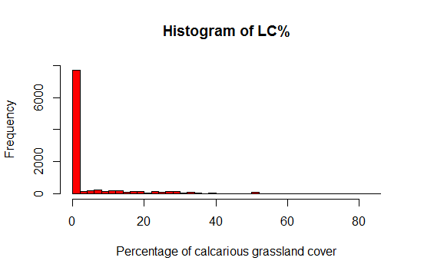Plot histogram
* Labelled values above 5% as high LC, less than as low
* Removed altitude values below 0 (all=-999)
* Plot histogram

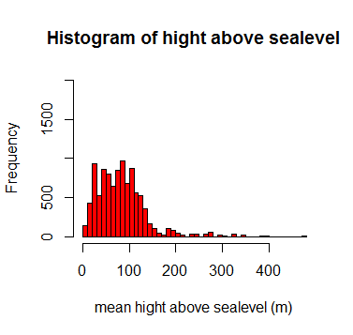

* Labelled values above 150m as high altitude, less than as low.
* Removed slope angle values below 0 (all=-999)
* Plot histogram

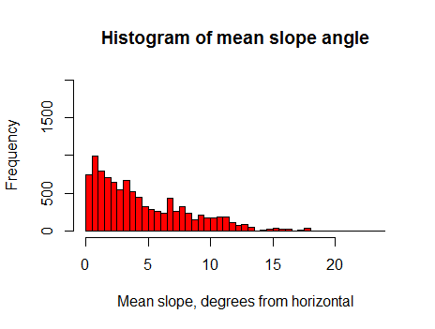

• Labelled values above 10 degrees as steep, less than as shallow.

Run models

model<-lm(meanday~LCper+factor(year),phenology.gis)

model<-lm(meanday~DEM_MEAN+factor(year),phenology.gis)

model<-lm(meanday~NORTHNESS_MEAN+factor(year),phenology.gis)

model<-lm(meanday~north+factor(year),phenology.gis)

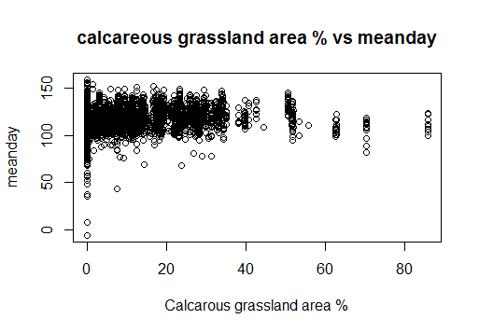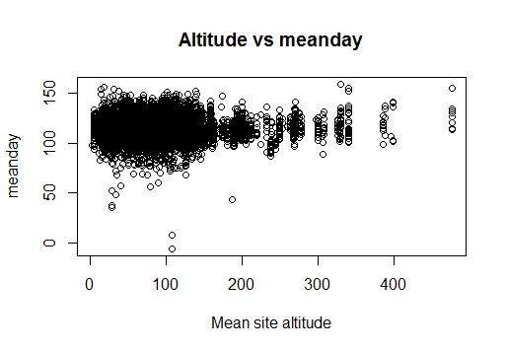model<-lm(meanday~SLOPE_MEAN+factor(year),phenology.gis)

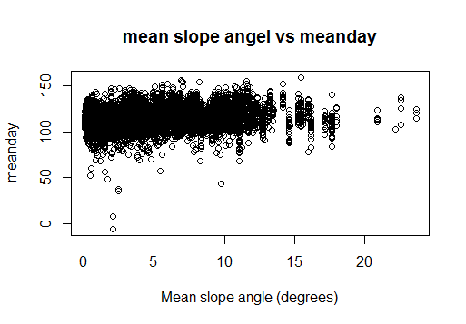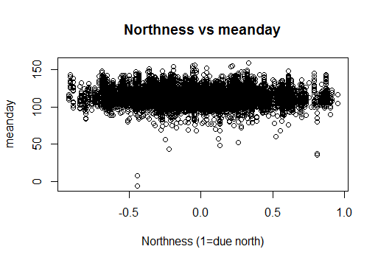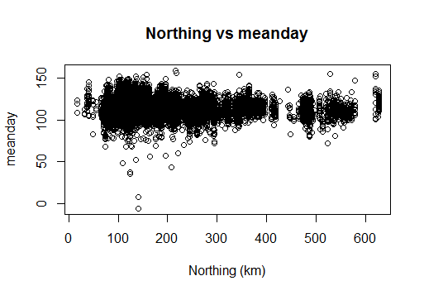

* Combine LC and slope
* High lc.shallow, high lc.steep, low lc.shallow, low lc.steep
* model<-lmer(meanday~LC.SLOPE+year+(1|siteno),phenology.gis)
* 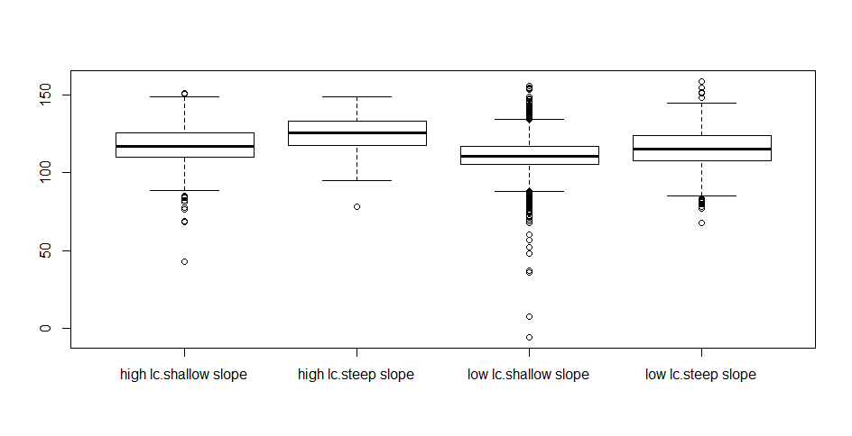plot boxplot

levels(phenology.gis$LC.SLOPE2)<-c("A","B","C","A")

levels(phenology.gis$LC.SLOPE2)

model2<-lmer(meanday~LC.SLOPE2+year+(1|siteno),phenology.gis)

anova(model,model2)

A=high lc.shallow & low lc.steep

